Experiment 2

Create a simple cloud software application for Property Buying & Rental process (In Chennai city) using any Cloud Service Provider to demonstrate SaaS include the necessary fields such as Buy, Rent, commercial, Rental Agreement , Rental Agreement, Area, place, Range, property value etc.

Step1: Creating a full software application involves significant development work and is beyond the scope of a simple text based conversation.

Allowing users to create accounts and login securely.

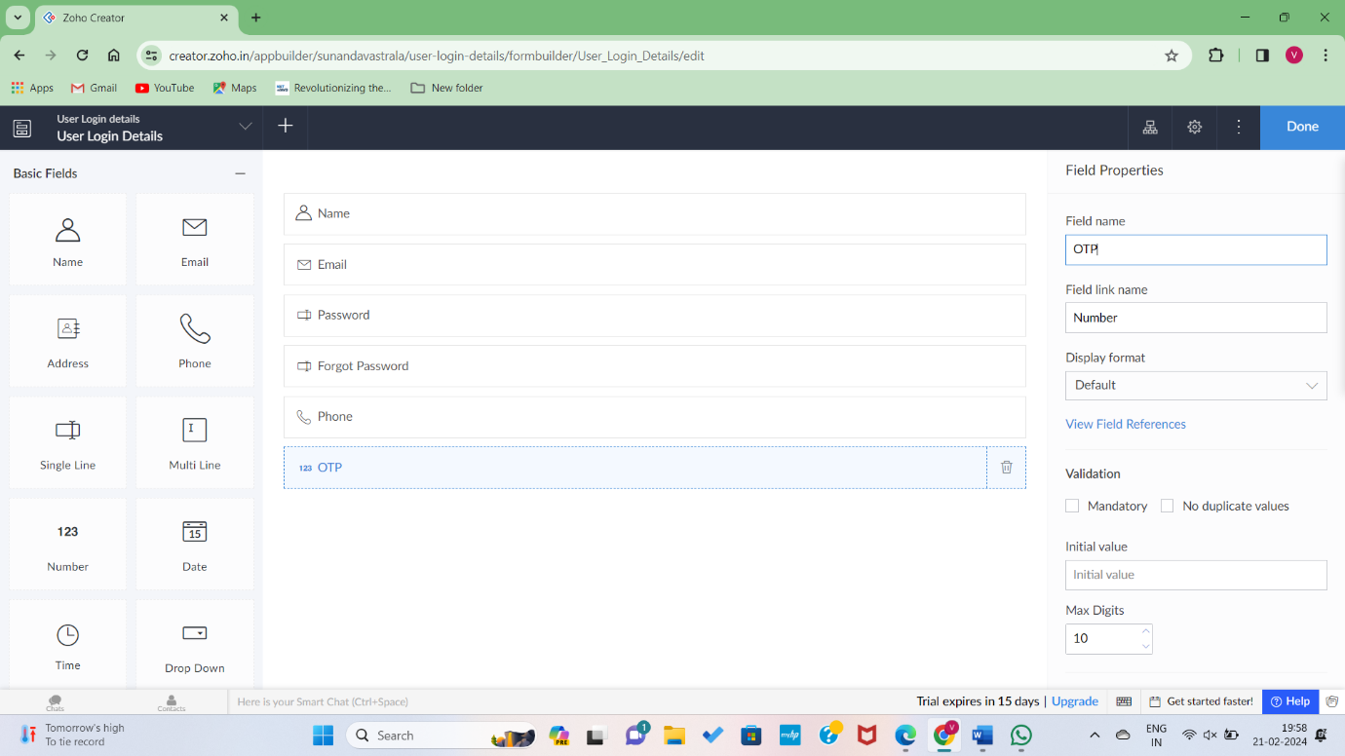Step2: User Details added successfully to the account.

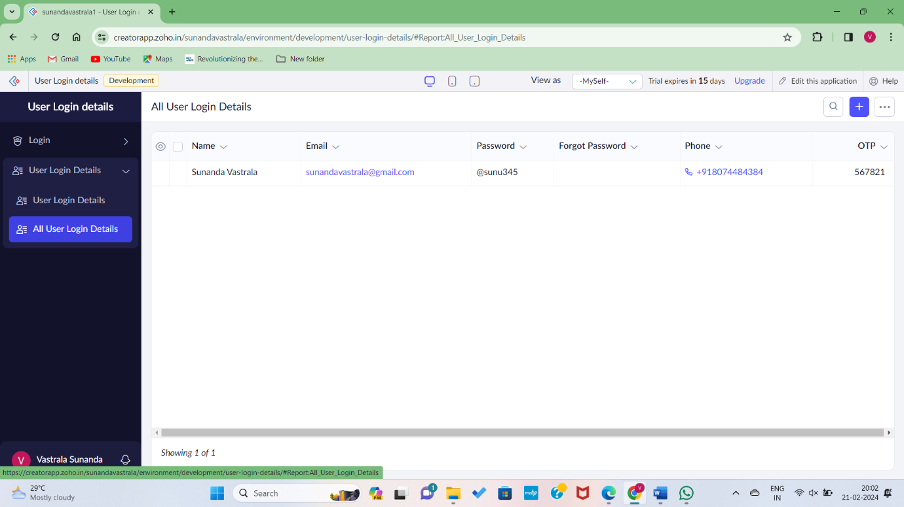

Step3: Creating a section for buying and renting, including filter properties like Residential, Commercial, area and price range.

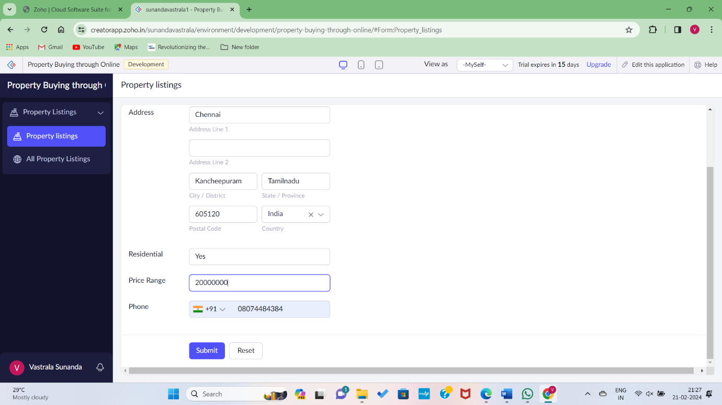

Step 4: Adding details to dataset Successfully.

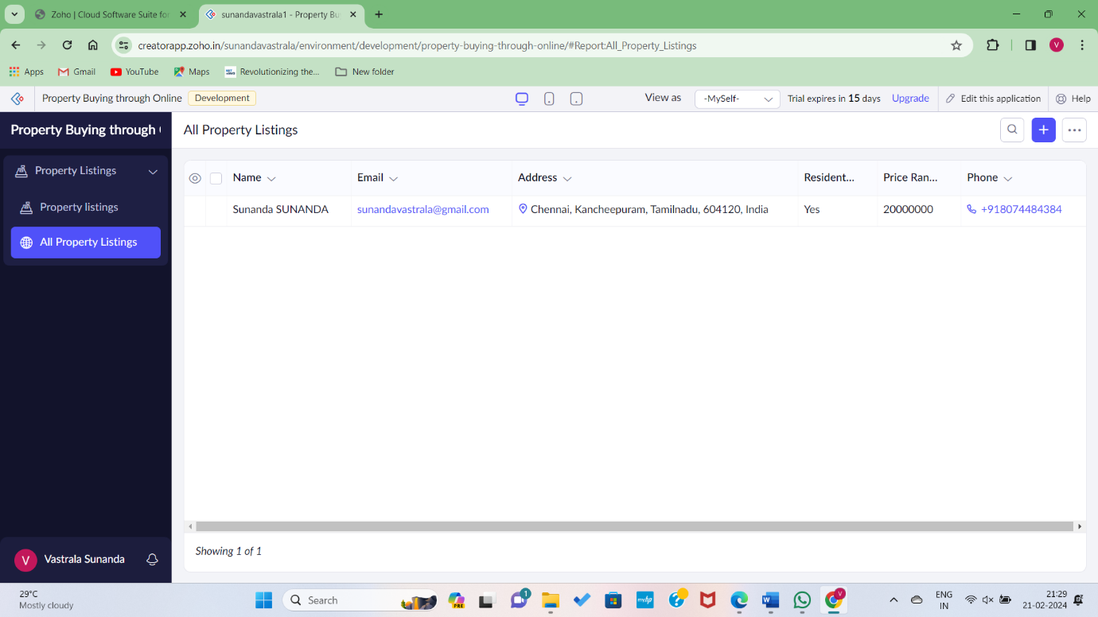

Step5: Implementing a feature for users to create and sign rental agreements online.

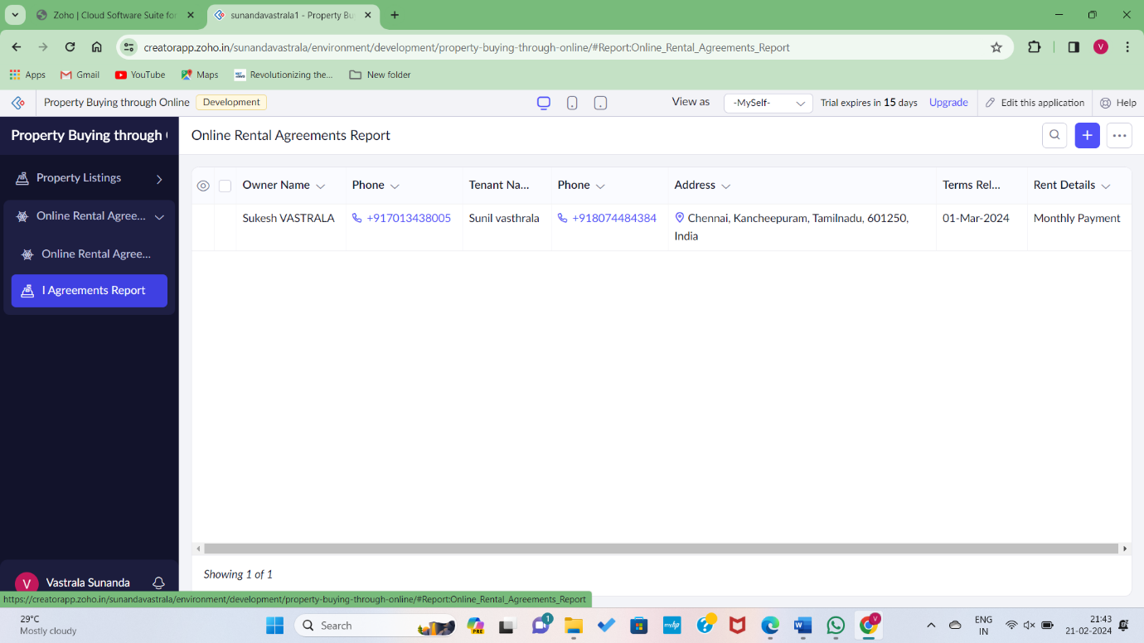

Step6: Displaying Properties on a map for better Visualization.

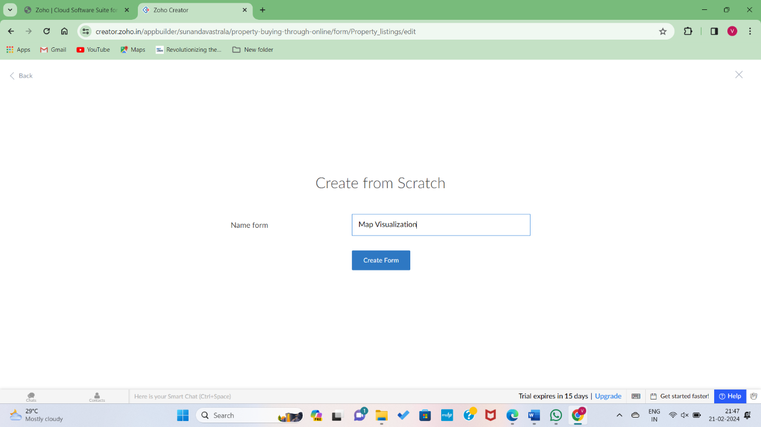

Step 7: Creating forms through the details of map visualization.

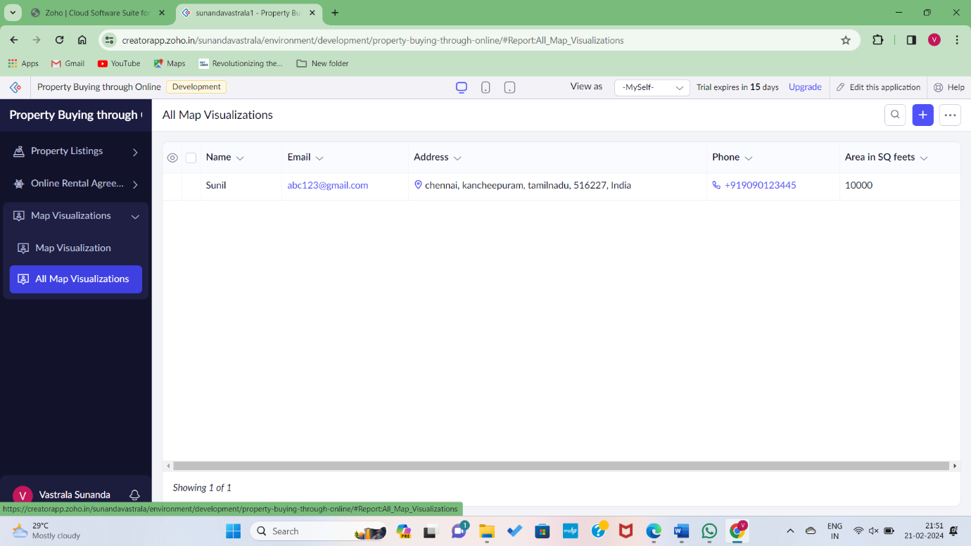

Step9: Completing process for Payment and Document.

